Bug_01:
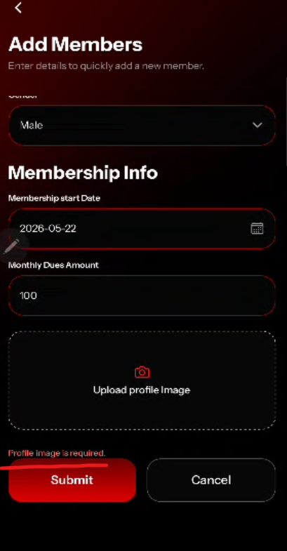
Error message should be little bit upward
Bug_02:
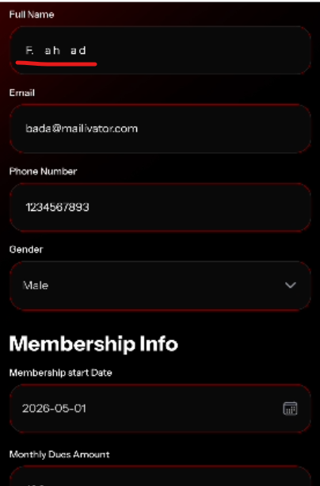
Full Name fields allowed extra spaces
Bug_03:
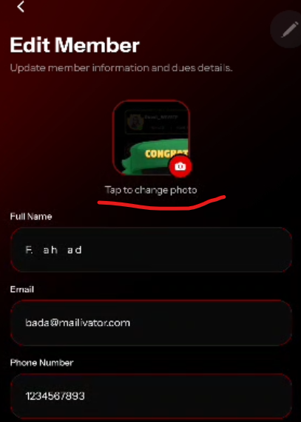
Image preview and delete options should be active or not ????
Bug_04:
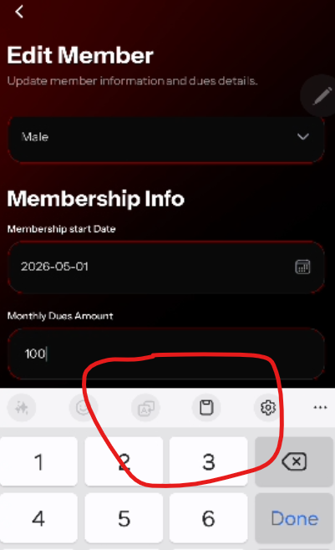
Save button is not visible when keypad is open

Bug_05:
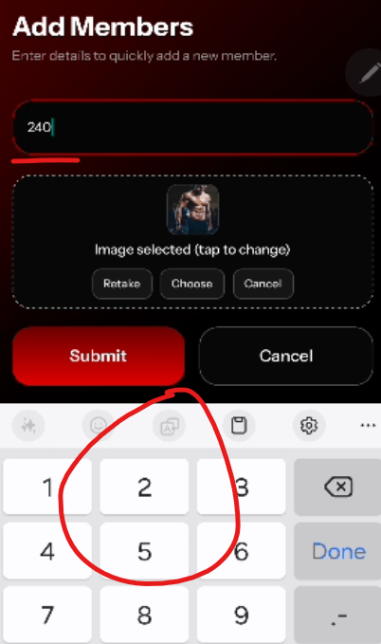
After updating the profile picture, automatically keypad opens and pointing towards monthly dues field.

Bug_06:
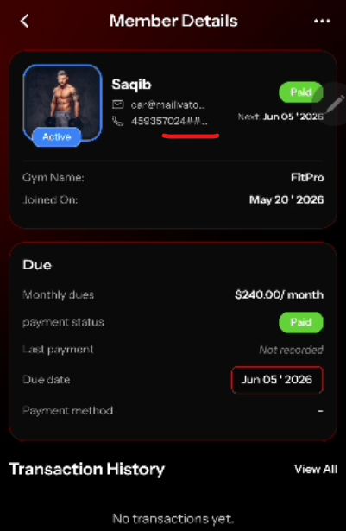
Phone Numbers field accept the special char and symbols
Bug_07:

When user goes to any other page and then back to member page, search bar should b clear
Bug_08:
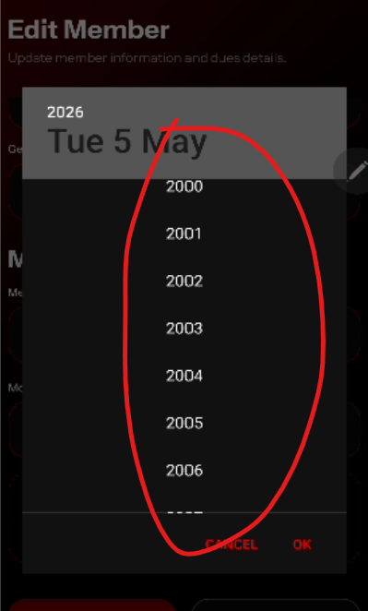

should be set to specific time period

Bug_09:
Member Details page should be completely scroll down

